**Ex No: 9**

**Date:**

**IMPLEMENT CODE OPTIMIZATION TECHNIQUES CONSTANT FOLDING**

**AIM:**

To write a C program to implement Constant Folding (Code optimization Technique).

**ALGORITHM:**

* The desired header files are declared.
* The two file pointers are initialized one for reading the C program from the file and one for writing the converted program with constant folding.
* The file is read and checked if there are any digits or operands present.
* If there is, then the evaluations are to be computed in switch case and stored.
* Copy the stored data to another file.
* Print the copied data file.

## PROGRAM:

#include<stdio.h>

#include<string.h>

void main() {

char s[20];

char flag[20]="//Constant";

char result,equal,operator;

double op1,op2,interrslt;

int a,flag2=0;

FILE *fp1,*fp2;

fp1 = fopen("input.txt","r");

fp2 = fopen("output.txt","w");

fscanf(fp1,"%s",s);

while(!feof(fp1)) {

if(strcmp(s,flag)==0) {

flag2 = 1;

}

if(flag2==1) {

fscanf(fp1,"%s",s);

result=s[0];

equal=s[1];

if(isdigit(s[2])&& isdigit(s[4])) {

if(s[3]=='+'||'-'||'*'||'/') {

operator=s[3];

switch(operator) {

case '+':

interrslt=(s[2]-48)+(s[4]-48);

break;

case '-':

interrslt=(s[2]-48)-(s[4]-48);

break;

case '*':

interrslt=(s[2]-48)*(s[4]-48);

break;

case '/':

interrslt=(s[2]-48)/(s[4]-48);

break;

default:

interrslt = 0;

break; }

fprintf(fp2,"/*Constant Folding*/\n");

fprintf(fp2,"%c = %lf\n",result,interrslt);

flag2 = 0;

}

} else {

fprintf(fp2,"Not Optimized\n");

fprintf(fp2,"%s\n",s);

}

} else {

fprintf(fp2,"%s\n",s);

}

fscanf(fp1,"%s",s);

}

fclose(fp1);

fclose(fp2);

}

**OUTPUT:**

**//output.txt**

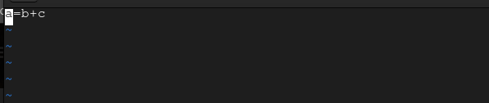



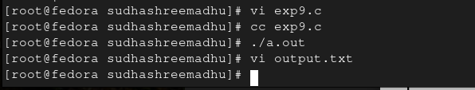

**RESULT:**